**PSA Batangas Concludes 35th Civil Registration Month Celebration**

### Date of Release: 06 March 2025

### Reference No. 2025-009

### C:\Users\CAF-WS-04\Downloads\5026c73e-67f1-4ef6-9adc-c1a3a7ced10c.jpg

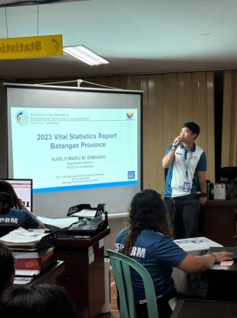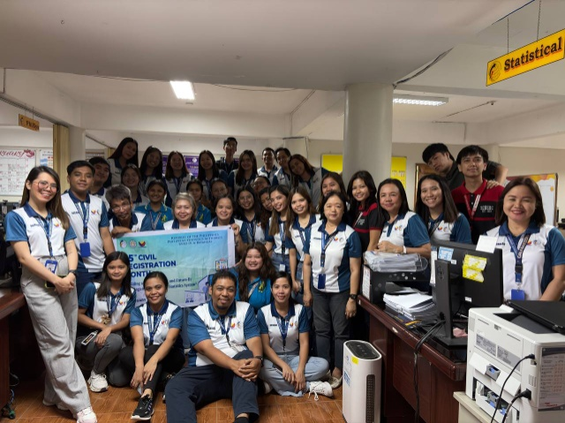

*Presentation of 2023 Batangas Vital Statistics Final Report by ROII Dimaano.*

*PSA Quiz Bee winners.*

*In photos: PSA employees, student immersionists, and on-the-job trainees during 35th CRM Closing Ceremony.*

The Philippine Statistics Authority (PSA) Batangas successfully wrapped up the 35th Civil Registration Month (CRM) celebration on February 28, 2025, marking the end of a month-long initiative in raising awareness about the importance of civil registration and vital statistics.

The activity featured the 2023 Batangas Vital Statistics Final Report presented by Registration Officer II Karlo Maru M. Dimaano. It provided valuable insights into demographic trends of birth, death, and marriage registrations. To further reinforce the importance of vital statistics, PSA employees, student immersionists, and on-the-job trainees actively participated in an engaging quiz competition designed to test their knowledge of the discussed statistics.

As the 35th CRM Month concluded, the Civil Registration Unit extended its gratitude to all personnel, stakeholders, and participants who contributed to the success of the event. The activities conducted throughout the CRM celebration emphasized the agency’s dedication to ensuring public awareness and accessibility of essential civil registration processes. It remains steadfast in its mission of delivering accurate and reliable civil registration services.

**RAUL MAXIMO B. TOLENTINO**Chief Statistical Specialist

*MMG / JLV*